COMMUNUTY TRANSPORT  Epping Forest & Harlow Community Transport is a charity that meets the needs of local people who for various reasons are unable to use conventional public transport.  volunteers needed  Car Drivers Minibus Drivers Trustees  Would you like to give something back to the  Community?  If so, volunteering is a great way to do this,  Out of pocket expenses are reimbursed.  Training provided.  Email: efct@efcommunitytransport.org.uk Website: www.efcommunitytransport.co.uk | 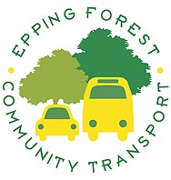  For all Membership details and enquires please telephone.  Epping OFFICE  01992 579556  Harlow OFFICE  01279 798876    