THE NAZEING LUNCH CLUB
for elderly Nazeing residents and their friends
The next lunch will take place on
Tuesday 3rd October, 2023
at the Highland Restaurant, Broxbourne
12.00 for 12.30 p.m.
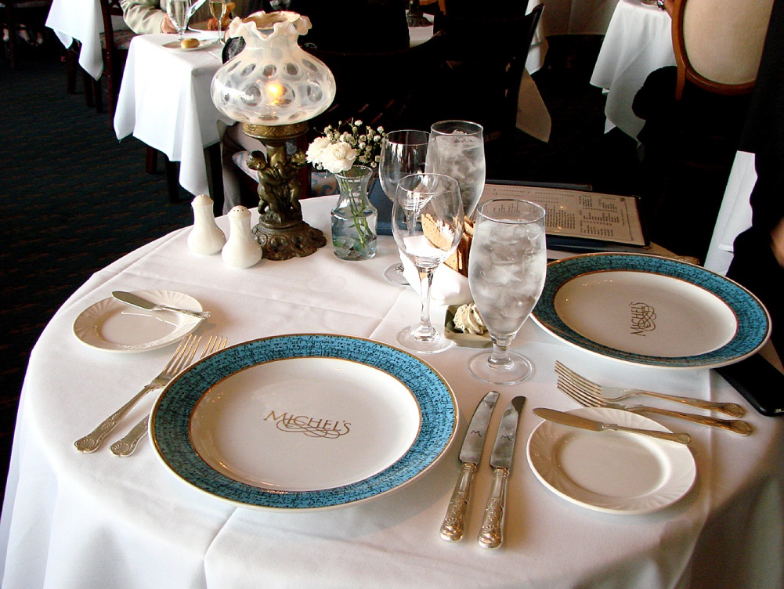
Following the success of the last meal,
Chef Jimmy will again surprise us with another main course of his own choice!! Desserts will be as usual from the main menu.
If you would like to join this happy social group,
please contact me for more information
Betty Brown 01992 893431

