COMMUNITY TRANSPORT  pART-TIME MINIBUS DRIVER  VACANCY  C392 Shopper Bus  Thursday & Friday 06:30-15:30.  This position offers a fulfilling opportunity for someone wishing to meet the needs of the  Nazeing Community.  Over 25 & driving licence with D1 entitlement is essential.  Email: efct@efcommunitytransport.org.uk Website: www.efcommunitytransport.co.uk | 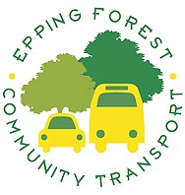  For an application form please email or telephone.  Epping OFFICE  01992 579556    