REMEMBRANCE SERVICE
ALL SAINTS CHURCH, BETTS LANE, NAZEING
EN9 2DB
Sunday 9th November, 2025

10.30am walk from the Triangle, Betts Lane to Church.
10.45am short ceremony including wreath laying at the Lychgate followed by a service in Church at 11am, led by Revd. Richard Attew

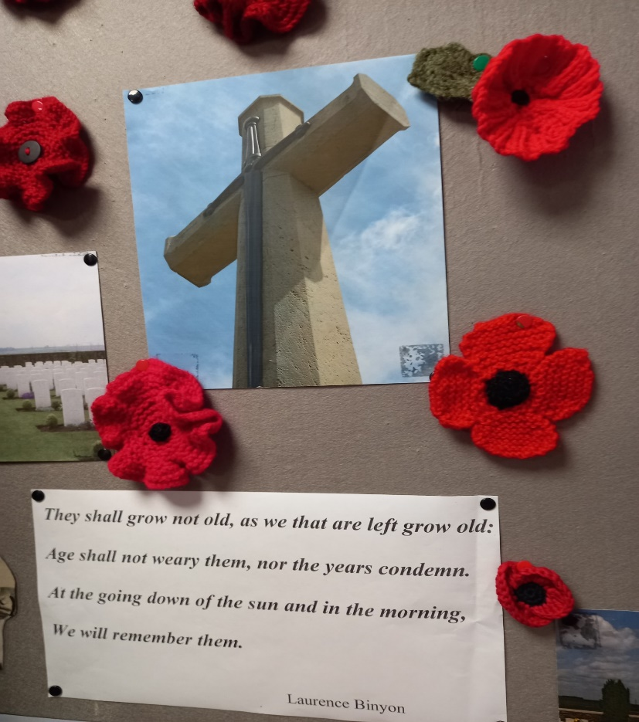

In this year which has marked milestone VE & VJ Anniversaries, bringing eventual peace, we remember all who paid the ultimate sacrifice who served for our nation. Remembering all surviving veterans and younger Forces today and their families, still cared for by the Royal British Legion when in need.

PRAY FOR PEACE

