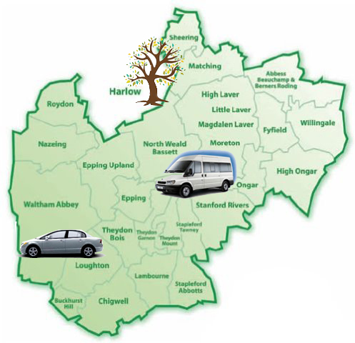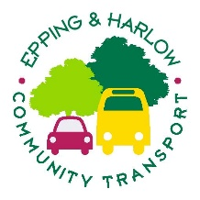
COMMUNITY MEETING
Supporting the 392 Bus Service
Residents are warmly invited to attend a community meeting to discuss the additional support being provided to the 392 bus route, following funding secured by the Parish Council.
This meeting will be an opportunity to:
- Hear about the planned support for the service
- Share your views and suggestions
- Discuss how the route can best support local residents
- Ask questions and provide feedback
📍 Venue: St Giles Church Hall
📅 Date: Wednesday 17 June
🕡 Time: 6:30pm – 7:30pm
(Doors open from approximately 6:15pm)
Epping & Harlow Community Transport and Nazeing Parish Council hope this meeting will provide a valuable opportunity for residents to help shape the future of this important local service.
Everyone welcome.

